Medical Lab Test Ordering & Result Delivery System

1. Project Overview
The proposed system is an electronic solution for medical laboratory test ordering, tracking, and secure result delivery. The project brief identifies three current problems: difficulty finding the required test result, results being mixed up between patients, and crowding in the laboratory.
Project sponsor: Laboratory Manager.
Business needs: reduce time loss, reduce human errors, and make test results easier to find.
Main requirements: order lab tests; manage patient information; track test status; enter and manage results; deliver results; and provide user access and security.
Constraints and issues: data privacy and security, user permissions, system availability, data accuracy, and possible integration with hospital systems.

2. Methodology
Recommended methodology: a small, phased System Development Life Cycle (SDLC) approach. It provides clear deliverables for each stage and is suitable for a student team working from defined requirements.
Stage | Activities | Deliverable
1. Planning & requirements | Meet the laboratory manager/users; document the current workflow, problems, user roles, and required features. | Approved requirements list
2. Analysis | Map the process from patient registration to test ordering, status updates, result entry, and delivery. Identify risks such as patient mix-ups. | Use cases and process/data requirements
3. Design | Design the database entities, user screens, navigation, and role-based permissions. Define how patient and result records are linked. | Database design, screen sketches, access matrix
4. Development | Build patient management, test ordering, status tracking, result management, and result delivery modules. | Working system modules
5. Testing | Test valid/invalid inputs, patient-result matching, permissions, missing data, and end-to-end workflows. | Test cases and defect log
6. Deployment & evaluation | Demonstrate the system, explain user procedures, collect feedback, and record improvements. | Demonstration, user guide, improvement list

Security principle: only authorized users should access or change patient records and results. The project should avoid exposing patient data in demonstrations or test examples.

3. Time Estimation
The estimates below are approximate working days, not confirmed deadlines. They assume a small student team, basic web/desktop functionality, and no complex live integration with a hospital system. Tasks D and E can be developed in parallel after design.
ID | Activity | Estimate (working days) | Predecessor(s) | Notes
A | Requirements gathering | 3 | — | Define users, problems, and requirements
B | System analysis | 4 | A | Analyze workflows and data
C | System design | 4 | B | Design screens, database, and access roles
D | Patient & test ordering module | 6 | C | Manage patients and create test orders
E | Test status & results module | 6 | C | Track status and enter results
F | Result delivery & security | 4 | D, E | Deliver results with role-based access
G | Integration and testing | 4 | F | Test accuracy, privacy, and end-to-end flow
H | Documentation and presentation | 3 | G | Prepare final report and demonstration

Estimated total elapsed duration: approximately 29 working days (about 6 weeks if weekends and review time are included). This is a schedule estimate; actual duration may change after requirements and technical constraints are confirmed.

4. Case Study

Scenario: A patient requests a laboratory test
A patient arrives at the laboratory and requests a test. A receptionist or authorized staff member searches for the patient or creates a patient record, then creates a test order linked to that patient. The system assigns an order identifier and marks the test as 'Ordered'. Laboratory staff update the status as the sample is processed. An authorized staff member enters and verifies the result. The system stores the result against the correct patient and order, then makes it available to an authorized recipient through the approved delivery method.

Expected system behavior
- Patient and test-order records must remain linked throughout the workflow.
- The test status should be visible to authorized users, reducing repeated questions and crowding.
- Only permitted roles can enter, edit, verify, or view sensitive results.
- Before delivery, staff should verify the patient identity and the matching order to reduce result mix-ups.
- The system should record important changes where feasible and handle unavailable or incomplete data safely.

Example acceptance checks
Check | Expected result
Create an order for a registered patient | A unique order is created and linked to the correct patient.
Search for an order | Authorized staff can find it using supported identifiers/status.
Update test status | The new status is saved and shown consistently.
Try to access a result without permission | Access is denied.
Deliver a verified result | The result is associated with the correct patient and order.

5. PERT Chart
The network below shows task dependencies. D and E are parallel activities; both must be completed before F begins.
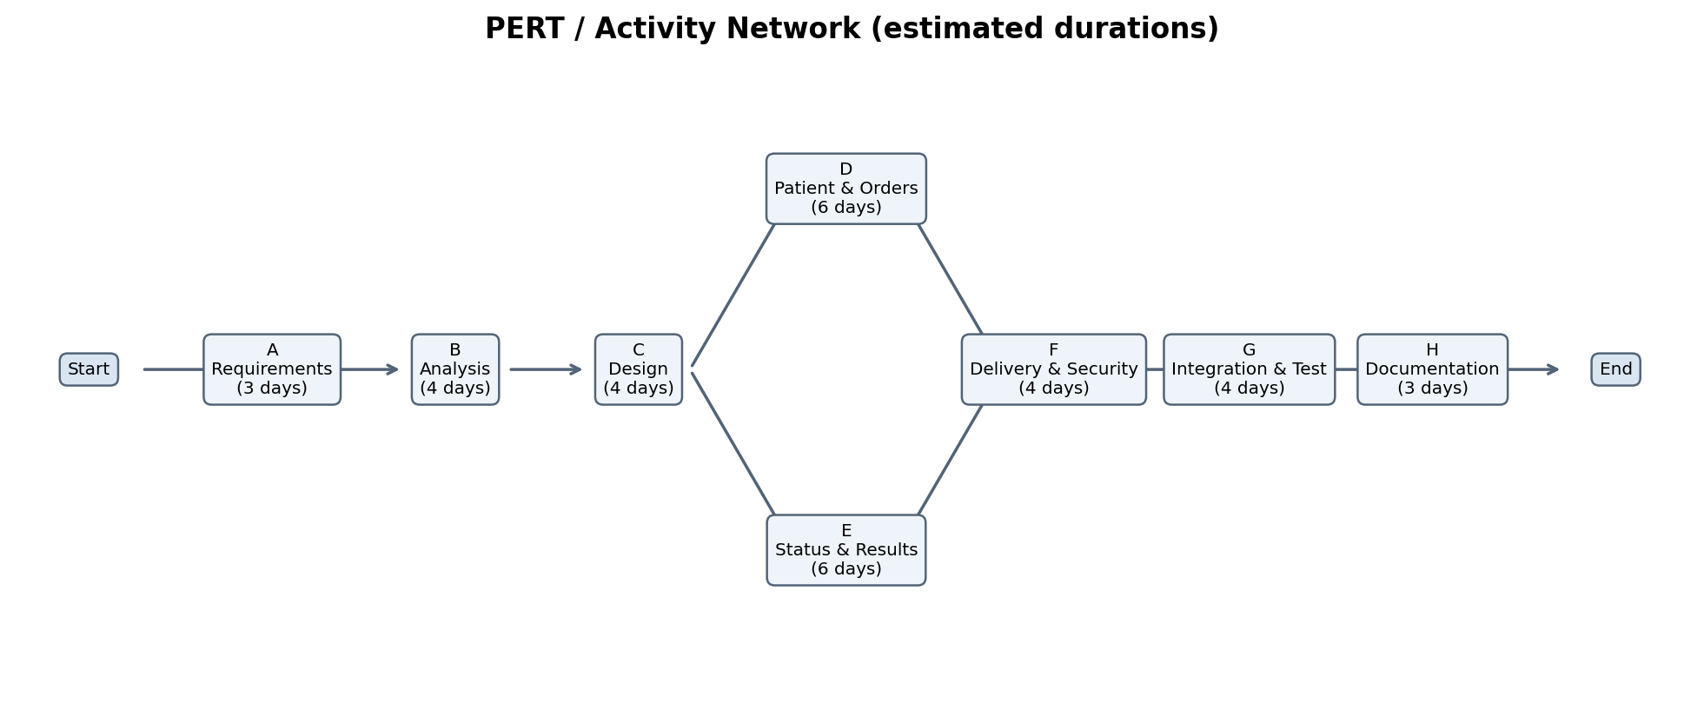
Activity durations are estimates. The longest dependency path is A → B → C → D/E → F → G → H; because D and E have the same estimated duration, either branch may determine the finish date unless actual progress differs.

6. Gantt Chart
Illustrative schedule starting 2 November 2026. The chart uses working-day offsets rather than fixed calendar completion dates.
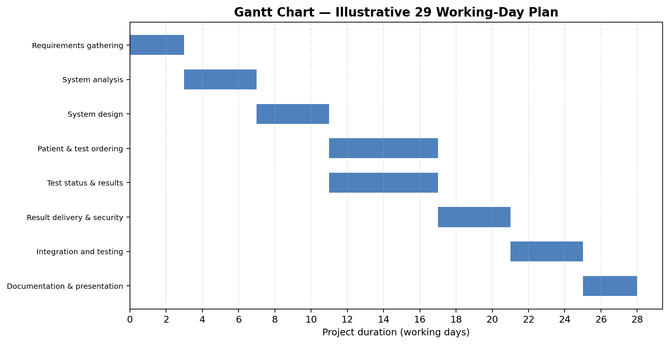

7. Assumptions and Risks
- The schedule assumes the team can work on parallel modules and receive timely feedback.
- Hospital-system integration is treated as a constraint to investigate, not a guaranteed feature in the first version.
- Patient privacy, role permissions, and data accuracy should be tested throughout development.
- If the project scope changes, update task estimates, dependencies, and the Gantt chart.

Source Basis
Project title, current problems, description, sponsor, business needs, requirements, business value, and constraints were taken from the supplied System Analysis & Design project brief. The methodology, case study, task durations, dependencies, and charts are proposed planning content created to complete the requested sections.

